PIZZA Sales SQL Queries
A.KPI’s
1.Total Revenue:
SELECT SUM(total_price) AS Total_Revenue from pizza_sales
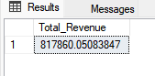
2.Average Order Value:
SELECT SUM(total_price) / COUNT(DISTINCT order_id)as Avg_Order_Value from pizza_sales
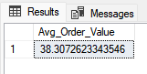
3.Total Pizza Sold:
SELECT SUM(quantity) as Total_Pizza_Sold from pizza_sales
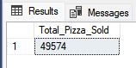
4.Total Orders:
SELECT COUNT(DISTINCT order_id) AS Total_Orders from pizza_sales
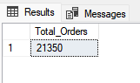
5.Avg Pizzas Per Order:
SELECT CAST(CAST(SUM(quantity) AS Decimal(10,2)) /
CAST(COUNT(DISTINCt order_id)AS Decimal(10,2)) AS Decimal(10,2)) As Avg_Pizzas_per_Order from pizza_sales
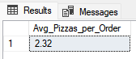
B. Charts Requirment
1. Total Trend for total orders:
SELECT DATENAME(DW, order_date) as order_day, COUNT(DISTINCT order_id) as Total_Orders
from pizza_sales
GROUP BY DATENAME(DW, order_date)
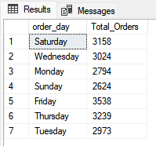
2.Monthly Trends for Orders:
SELECT DATENAME(MONTH, order_date) AS Month_Name, COUNT(DISTINCT order_id) AS Total_Orders
from pizza_sales
GROUP By DATENAME(MONTH, order_date)
ORDER BY Total_Orders DESC
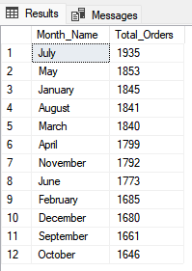
3. Percentage of Sales by Pizza Category:
SELECT pizza_category, sum(total_price) as Total_Sales, sum(total_price) * 100 /
(SELECT sum(total_price) from pizza_sales WHERE MONTH(order_date) = 1) AS PCT_Total_Sales
from pizza_sales
WHERE MONTH(order_date) = 1
GROUP BY pizza_category
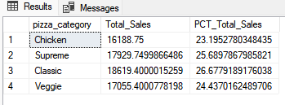
4.Percentage of Sales By Pizza Size:
SELECT pizza_size,CAST(sum(total_price)as Decimal(10,2)) as Total_Sales, CAST(sum(total_price) * 100 /
(SELECT sum(total_price) from pizza_sales Where Datepart(QUARTER,order_date) = 1) AS Decimal(10,2)) AS PCT
from pizza_sales
Where Datepart(QUARTER,order_date) = 1
GROUP BY pizza_size
Order By PCT DESC
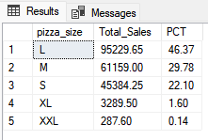
5. Total Pizzas Sold by Category:
SELECT pizza_category, SUM(quantity) as Total_Quantity_Sold
FROM pizza_sales
WHERE MONTH(order_date) = 2
GROUP BY pizza_category
ORDER BY Total_Quantity_Sold DESC
6. Top 5 Pizzas by Revenue:
SELECT Top 5 pizza_name, sum(total_price) as Total_Revenue from pizza_sales
GROUP BY pizza_name
Order By Total_Revenue DESC
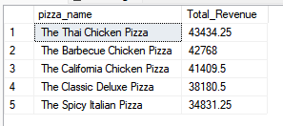
7. Bottom 5 Pizzas by Revenue:
SELECT Top 5 pizza_name, SUM(total_price) AS Total_Revenue
FROM pizza_sales
GROUP BY pizza_name
ORDER BY Total_Revenue
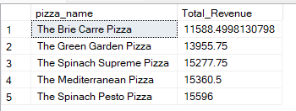
9. Top 5 Pizzas by Quantity
SELECT Top 5 pizza_name, SUM(quantity) AS Total_Pizza_Sold
FROM pizza_sales
GROUP BY pizza_name
ORDER BY Total_Pizza_Sold DESC
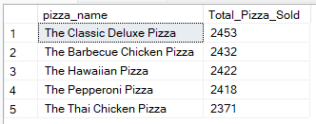
10. Bottom 5 Pizzas by Quantity
SELECT TOP 5 pizza_name, SUM(quantity) AS Total_Pizza_Sold
FROM pizza_sales
GROUP BY pizza_name
ORDER BY Total_Pizza_Sold
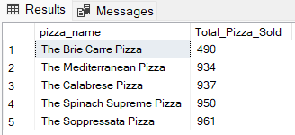
11. Top 5 Pizzas by Total Orders
SELECT Top 5 pizza_name, COUNT(DISTINCT order_id) AS Total_Orders
FROM pizza_sales
GROUP BY pizza_name
ORDER BY Total_Orders DESC
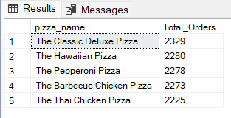
12. Borrom 5 Pizzas by Total Orders
SELECT Top 5 pizza_name, COUNT(DISTINCT order_id) AS Total_Orders
FROM pizza_sales
GROUP BY pizza_name
ORDER BY Total_Orders
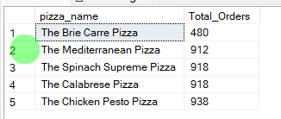
NOTE
If you want to apply the pizza_category or pizza_size filters to the above queries you can use WHERE clause. Follow some of below examples
SELECT Top 5 pizza_name, COUNT(DISTINCT order_id) AS Total_Orders
FROM pizza_sales
WHERE pizza_category = 'Classic'
GROUP BY pizza_name
ORDER BY Total_Orders ASC

